**Pizza Sales Data Analysis SQL Queries**

**A. KPI QUERY**

**1. Total Revenue**

SELECT

ROUND(SUM(total_price), 0) AS Total_Revenue

FROM pizza_sales;

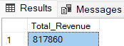

**2. AVG Order Value**

SELECT

SUM(total_price) /

COUNT(DISTINCT order_id) AS AVG_order_value

FROM pizza_sales;

**3.Total Quantity of Pizza Sold**

SELECT

SUM(quantity) AS Total_Quantity_of_Pizzas_Sold

FROM pizza_sales;

**4.Total Orders**

SELECT

COUNT(DISTINCT order_id) AS Total_Orders

FROM pizza_sales;

**5.AVG Pizza per order**

SELECT

CAST(CAST(SUM(quantity) AS DECIMAL(10,2)) /

CAST(COUNT(DISTINCT order_id) AS DECIMAL(10,2)) AS DECIMAL(10,2)) AS AVG_Pizza_per_order

FROM pizza_sales

**B. CHARTS QUERY**

**1. Daily Trend for Total Orders**

SELECT DATENAME(DW, order_date) AS Date_name, COUNT(DISTINCT order_id) AS Total_Orders

FROM pizza_sales

GROUP BY DATENAME(DW, order_date);

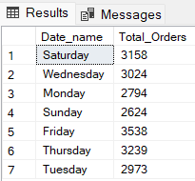

**2. Monthly Trend for Total Orders**

SELECT

DATENAME(MONTH, order_date) AS Month_name,

COUNT(DISTINCT order_id) AS Total_orders

FROM pizza_sales

GROUP BY DATENAME(MONTH, order_date)

ORDER BY Total_orders DESC;

**3. Percentage of Sales by pizza_category**

WITH temp_table AS (

SELECT

pizza_category, SUM(total_price) AS total_sales,

SUM(total_price) AS total_price

FROM pizza_sales

WHERE MONTH(order_date) = 1

GROUP BY pizza_category

)

SELECT

pizza_category, total_sales,

total_price * 100.0 / (SELECT SUM(total_price) FROM temp_table) AS percentage_of_total

FROM temp_table;

**#NOTE**

**To apply MONTH, QUARTER, WEEK filters to the queries,**

**You can use the WHERE CLAUSE.**

**Follow some of the below examples to execute filters.**

WITH temp_table AS (

SELECT

pizza_category, SUM(total_price) AS total_sales,

SUM(total_price) AS total_price

FROM pizza_sales

WHERE MONTH(order_date) = 1

GROUP BY pizza_category

)

SELECT

pizza_category, total_sales,

total_price * 100.0 / (SELECT SUM(total_price) FROM temp_table) AS percentage_of_total

FROM temp_table;

Here MONTH(order_date) = 1 indicates that the output is for the month of January which is the 1st month of the year.

Similarly MONTH(order_date) = 4 will indicate the month of April.

WITH temp_table AS (

SELECT

pizza_category, SUM(total_price) AS total_sales,

SUM(total_price) AS total_price

FROM pizza_sales

WHERE DATEPART(QUARTER, order_date) = 1

GROUP BY pizza_category

)

SELECT

pizza_category, total_sales,

total_price * 100.0 / (SELECT SUM(total_price) FROM temp_table) AS percentage_of_total

FROM temp_table;

Here DATEPART(QUARTER, order_date) = 1 indicates that the output is for the 1st Quarter of the year.

Similarly, DATEPART(QUARTER, order_date) = 3 will indicate the 3rd Quarter of the year.

**4. Percentage of Sales by Pizza_Size**

WITH temp_table AS (

SELECT

pizza_size, SUM(total_price) AS total_sales,

SUM(total_price) AS total_price

FROM pizza_sales

WHERE MONTH(order_date) = 1

GROUP BY pizza_size

)

SELECT

pizza_size, ROUND(total_sales, 2) AS total_sales,

ROUND(total_price * 100.0 / (SELECT SUM(total_price) FROM temp_table), 2) AS percentage_of_total

FROM temp_table

ORDER BY percentage_of_total DESC;

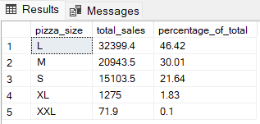

**5. TOP 5 pizza as per total_revenue**

SELECT TOP 5

pizza_name,

ROUND(SUM(total_price), 2) AS total_revenue

FROM

pizza_sales

GROUP BY

pizza_name

ORDER BY

total_revenue DESC;

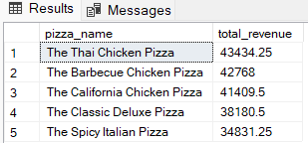

**#NOTE**

**At the above-mentioned query**

LIMIT 5; **can also be used at the last by erasing the** TOP 5

**Similarly, for all the queries where BOTTOM & TOP are required.**

**6. BOTTOM 5 pizza as per total_revenue**

SELECT TOP 5

pizza_name,

ROUND(SUM(total_price), 2) AS total_revenue

FROM

pizza_sales

GROUP BY

pizza_name

ORDER BY

total_revenue ASC;

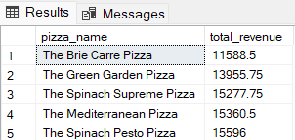

**7. TOP 5 pizza as per total_quantity**

SELECT TOP 5

pizza_name,

ROUND(SUM(quantity), 2) AS total_quantity

FROM

pizza_sales

GROUP BY

pizza_name

ORDER BY

total_quantity DESC;

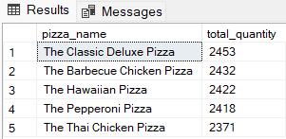

**8. BOTTOM 5 pizza as per total-quantity**

SELECT TOP 5

pizza_name,

ROUND(SUM(quantity), 2) AS total_quantity

FROM

pizza_sales

GROUP BY

pizza_name

ORDER BY

total_quantity ASC;

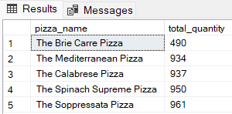

**9. TOP 5 pizza as per total_orders**

SELECT TOP 5

pizza_name,

COUNT(DISTINCT order_id) AS total_orders

FROM

pizza_sales

GROUP BY

pizza_name

ORDER BY

total_orders DESC;

**10. BOTTOM 5 pizza as per total_orders**

SELECT TOP 5

pizza_name,

COUNT(DISTINCT order_id) AS total_orders

FROM

pizza_sales

GROUP BY

pizza_name

ORDER BY

total_orders ASC;

